**Final project: Automatically defend from DoS and DDoS traffic flood attacks**

Our project deals with understanding and examining DoS and DDoS attacks, and what are the solutions for them. In particularly, we will discuss and handle with traffic flood attacks on web servers, and will try to develop our own software or algorithm to block or to give any immediately pragmatic solution.

We are aware that there are solutions for DoS and DDoS attacks, but none of them deals with traffic flood attacks. This causes that anyone who wants to purchase a development to defend from traffic flood, needs to purchase a bigger development, which he does not really need, and that makes this solution expensive and not practical.

Therefore, our audience are private businesses or anyone who does not need a grandiose solution for a spotted problem.

Our main goal is to achieve our own development, which would automatically identify and analyze a traffic flood attack, defend the server from it, and in need - will block any IP or sub-net which the flood comes from.

Our main idea is to create a script with an algorithm which blocks unwanted traffic and runs on a CDN server, which all the packets that are intended to the server, passes through it.

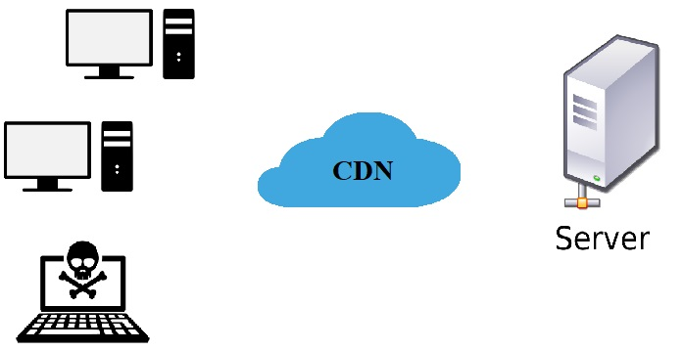

Advisor: Dr. Amit Dvir

Students:

Yinon Cohen 203526991

Maor Shabtay 305036162